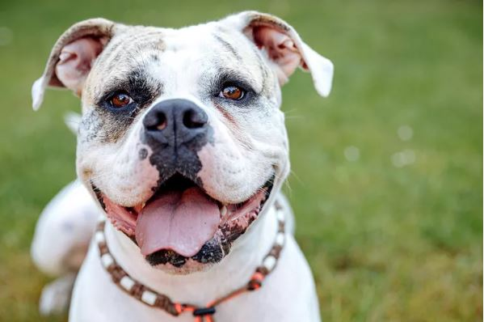

**1. American Bulldog**

**Droopy-jowled and rambunctious, the**[**American bulldog**](https://www.dailypaws.com/dogs-puppies/dog-breeds/american-bulldog)**is long-legged cousin of the**[**English bulldog**](https://www.dailypaws.com/dogs-puppies/dog-breeds/bulldog)**. They immigrated to the American colonies in the 17th century, where**[**they worked alongside butchers and farmers**](http://www.ababulldogs.com/history.html)**. American bulldogs love to play and run around, but be careful with your pup in high temperatures (they're prone to overheating).**

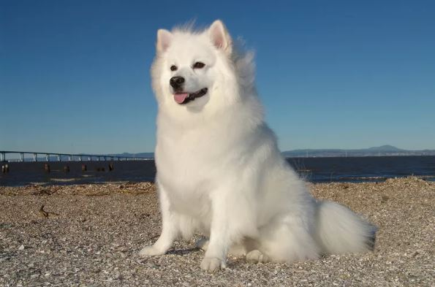

## 2. American Eskimo Dog

**Despite the name, Inuit peoples have nothing to do with the**[**American Eskimo dog**](https://www.dailypaws.com/dogs-puppies/dog-breeds/american-eskimo-dog)**. The dogs' origins are actually in Germany, and their ancestors, the**[**German spitz**](https://www.dailypaws.com/dogs-puppies/dog-breeds/german-spitz)**, came to the U.S. with immigrant families. When**[**anti-German prejudice swept the nation**](https://naeda.org/2020/01/11/eskie-essence-and-instincts/)**during the World Wars, the name was changed as the breed was further refined. Today, American Eskimo dogs and German spitz dogs are separate breeds registered with the American Kennel Club.**

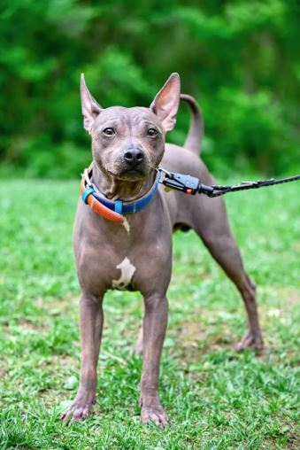

## 3. American Hairless Terrier

[**American hairless terriers**](https://www.dailypaws.com/dogs-puppies/dog-breeds/american-hairless-terrier)**are the only naked dog breed native to the U.S.**[**This hairless dog**](https://www.dailypaws.com/living-with-pets/pet-compatibility/hairless-dog-breeds)**is small, spunky, and has a typical terrier etude. While you might want to tuck her into your purse and carry her around all day, she's a pup who wants to keep her paws moving with**[**daily walks**](https://www.dailypaws.com/dogs-puppies/dog-exercise-play/how-often-do-you-walk-your-dog)**and playtime.**

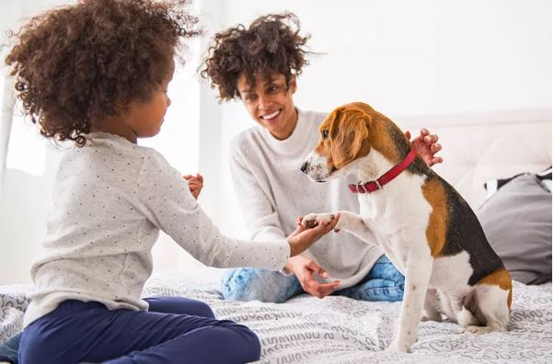

## 4. American Foxhound

**If American dogs had a founding father, it would be the gentle and talkative**[**American foxhound**](https://www.dailypaws.com/dogs-puppies/dog-breeds/american-foxhound)**. George Washington himself was instrumental in developing the breed: Before he became the nation's first president, Washington bred**[**English foxhounds**](https://www.dailypaws.com/dogs-puppies/dog-breeds/english-foxhound)**with French hounds to create a new breed perfectly suited for fox hunting in the U.S. countryside**

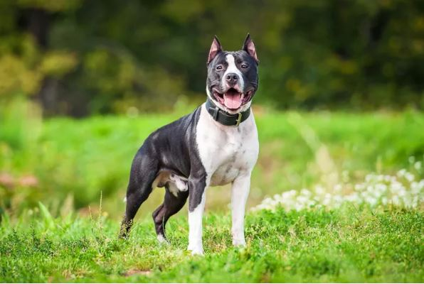

## 5. American Staffordshire Terrier

**Although the**[**American Staffordshire terrier**](https://www.dailypaws.com/dogs-puppies/dog-breeds/american-staffordshire-terrier-amstaff)**'s ancestors were bred for fighting and bull baiting, today's AmStaffs are far removed from their past. Well-trained and socialized AmStaffs can**[**make excellent playmates for children**](https://www.dailypaws.com/living-with-pets/pet-compatibility/best-dog-breeds-for-kids)**, are eager to**[**learn new tricks**](https://www.dailypaws.com/dogs-puppies/dog-training/basic/dog-tricks)**, and will always be ready to join their humans on a long walk.**

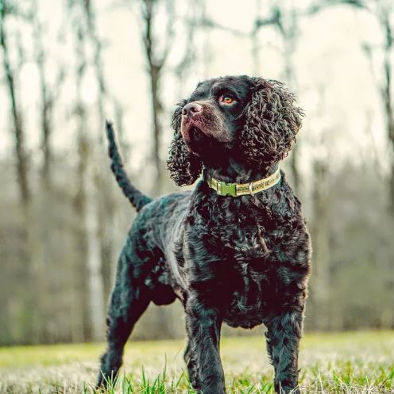

## 6. American Water Spaniel

**The curly-coated**[**American water spaniel**](https://www.dailypaws.com/dogs-puppies/dog-breeds/american-water-spaniel)**'s origins are a little bit of a mystery, but what is clear is that the dogs were bred in Wisconsin as working gun dogs. Their**[**thick double coat**](https://www.dailypaws.com/living-with-pets/pet-compatibility/double-coated-dogs)**and webbed feet mean these pups are**[**perfectly designed to retrieve birds**](https://www.dailypaws.com/living-with-pets/pet-compatibility/bird-dog-breeds)**for their human hunting companions, both on land and in the cold Northern waters**.

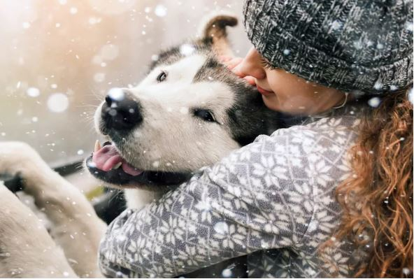

## 7. Alaskan Malamute

## Although the American Eskimo dog doesn't have Arctic origins, the [Alaskan malamute](https://www.dailypaws.com/dogs-puppies/dog-breeds/alaskan-malamute) walked side-by-side with his humans across the Bering Strait into present-day Alaska. [They're smart](https://www.dailypaws.com/living-with-pets/pet-compatibility/smartest-dog-breeds), athletic, and eager to please the humans they love most. Malamutes are also [quite chatty and will howl](https://www.dailypaws.com/dogs-puppies/dog-behavior/common-dog-behaviors/dog-howling) to let you know exactly what they want (more treats, please).

## dog no 8.JPG 8. Australian Shepherd

**The**[**Australian shepherd**](https://www.dailypaws.com/dogs-puppies/dog-breeds/australian-shepherd)**isn't really Australian at all, though their ancestors did take a detour in the Land Down Under before coming to the U.S. The**[**active dogs**](https://www.dailypaws.com/living-with-pets/pet-compatibility/active-dog-breeds)**are actually staples of cowboy culture in the American West, are a good match for high-energy families, and are the**[**most popular American dog breed**](https://www.dailypaws.com/living-with-pets/pet-compatibility/most-popular-dog-breeds)**.**

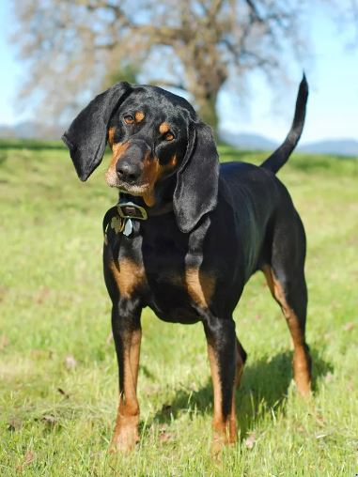

## 9. Black and Tan Coonhound

## With their floppy ears, soft eyes, and impeccable sniffers, [black and tan coonhounds](https://www.dailypaws.com/dogs-puppies/dog-breeds/black-and-tan-coonhound) are [working-class hunting dogs](http://coonhuntingclub.com/the-black-and-tan-coon-hound/). Black and tans worked hand-in-paw with humans to hunt, and they were trained to "tree" their prey (typically racoons), meaning they would chase it up a tree and bark to point out where it was cornered.

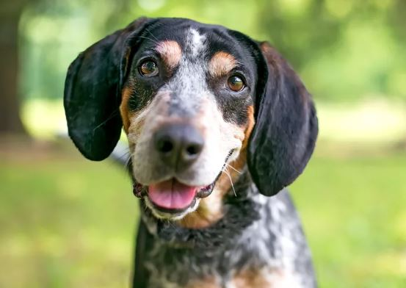

## 10. Bluetick Coonhound

**Another hunting dog, the**[**bluetick coonhound**](https://www.dailypaws.com/dogs-puppies/dog-breeds/bluetick-coonhound)**is known for his powerful nose and sing-songy baying. Blueticks are also known for treeing their prey and are capable of following a trail even if the scent is several days old. They are the State Dog of Tennessee**.

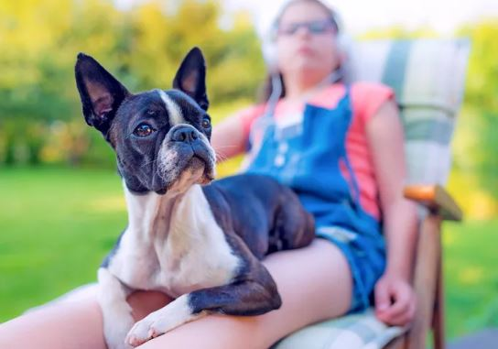

## 11. Boston Terrier

## [Boston terriers](https://www.dailypaws.com/dogs-puppies/dog-breeds/boston-terrier), with their snazzy built-in tuxedos, are known as the "American Gentlemen." These [small dogs](https://www.dailypaws.com/living-with-pets/pet-compatibility/small-dog-breeds) don't need a lot of space to be happy, and after playtime you'll typically find them snoring on the couch. Bostons are excellent companions for any family—President Gerald Ford even grew up with a Boston terrier!

## dog no 12.JPG

## 12. Boykin Spaniel

## Some dogs have been around for centuries, but the [boykin spaniel](https://www.dailypaws.com/dogs-puppies/dog-breeds/boykin-spaniel) was developed entirely in the 1900s. They can trace their history back to a single stray dog found in South Carolina, and today they're rarely found outside of the swampy American Southeast.

## dog no 13.JPG

## 13. Carolina Dog

**Sometimes called the "American dingo,"**[**Carolina dogs**](https://www.dailypaws.com/dogs-puppies/dog-breeds/carolina-dog)**weren't bred and developed by enthusiasts—they were**[**discovered running free in the 1970s**](https://www.thecolumbiastar.com/articles/trainers-visit-s-c-s-original-native-dog/)**, and it's believed they were Native American companion dogs. Because of their recent, wild history, Carolina dogs can be shy and suspicious around people.**

## 

## dog no 14.JPG

## 14. Catahoula Leopard Dog

## The [Catahoula leopard dog](https://www.dailypaws.com/dogs-puppies/dog-breeds/catahoula-leopard-dog) dates back to the Louisiana Territory's beginnings. Originally called the "Catahoula leopard cur," the pup's name officially changed when he became the State Dog of Louisiana in 1979. Catahoulas have striking merle coats and need a [large, fenced-in yard](https://www.dailypaws.com/living-with-pets/pet-friendly-home/dog-fence) to fulfill their hunting and herding instincts

## dog no 15.JPG.

## 15. Chesapeake Bay Retriever

**The only American-bred retriever, the**[**Chesapeake Bay retriever**](https://www.dailypaws.com/dogs-puppies/dog-breeds/chesapeake-bay-retriever)**is the perfect pup for fetching waterfowl from cold, Northeastern waters—which is exactly what she was bred for. Even if you're not into hunting, these dogs need to be**[**kept busy with hiking trips**](https://www.dailypaws.com/dogs-puppies/dog-exercise-play/how-to-hike-with-your-dog)**,**[**agility competitions**](https://www.dailypaws.com/dogs-puppies/dog-training/agility-competitive/dog-agility-training)**, or**[**long games of fetch**](https://www.dailypaws.com/dogs-puppies/dog-training/basic/how-to-teach-dog-fetch)**.**

## dog no 16.JPG

## 16. Miniature American Shepherd

## Although [miniature American shepherds](https://www.dailypaws.com/dogs-puppies/dog-breeds/miniature-american-shepherd) are about half the size of their Aussie ancestors, they're every bit as friendly, smart, and zoom. They're a newer dog (breeders began developing these pint-sized Aussies in the 1960s), and are sometimes referred to as "miniature Australian shepherds."

## dog no 17.JPG

## 17. Mountain Cur

## Spend all your free time outside? The [mountain cur](https://www.dailypaws.com/dogs-puppies/dog-breeds/mountain-cur) will be by your side. Originally a working dog for early U.S. settlers, these pups were so valuable to the pioneers that they were often carried by pack animals (or [even by their humans](http://www.omcba.com/)!) during travel. Today, they're more than happy to walk through the prairies and mountains on their own four paws.

## dog no 18.JPG

## 18. Rat Terrier

## Little [rat terriers](https://www.dailypaws.com/dogs-puppies/dog-breeds/rat-terrier) were first reliable Midwestern farmhands, but these tenacious terriers traded in their 9-to-5s to be full-time house dogs. But that doesn't mean rat terriers are going to snooze on the couch all day—these little guys need daily exercise and stimulation so they don't become bored.

## dog no 19.JPG

## 19. Toy Fox Terrier

## There are three types of fox terriers: [smooth](https://www.dailypaws.com/dogs-puppies/dog-breeds/smooth-fox-terrier), [wire](https://www.dailypaws.com/dogs-puppies/dog-breeds/wire-fox-terrier), and toy. Though the larger smooth and wire varieties were born across the pond in England, [toy fox terriers](https://www.dailypaws.com/dogs-puppies/dog-breeds/toy-fox-terrier) were developed Stateside. The perfect balance between a feisty terrier and playful [toy breed](https://www.dailypaws.com/living-with-pets/pet-compatibility/toy-dog-breeds), these pups love to play and learn tricks.

## dog no 20.JPG

## 20. Treeing Walker Coonhound

## [Treeing Walker coonhounds](https://www.dailypaws.com/dogs-puppies/dog-breeds/treeing-walker-coonhound) are another American hunting breed known for their love for exercise and the outdoors. But you don't have to live on vast rural acreage to make one happy; Treeing Walker coonhounds are totally adaptable, and all they need to be happy is love from their favorite person.